Kierra McCallum, Ayman Ibrahim, Zack Munford

Meezy Cutz

Table of Contents

1 Introduction

* 1. Purpose and Scope
  2. Product over
  3. Structure of Document

1. Project Management Plan
   1. Project organization
   2. Lifecycle model used
   3. Hardware and software resource requirements
   4. WBS, Deliverables and schedule
2. Requirement Specifications
   1. Stakeholders for the system
   2. Use case model
      1. Graphic use case model
      2. Textual description for each use case
   3. Rationale for use case model
   4. Non-functional requirements
3. Architecture
   1. Architectural Design
   2. Technology, software, and hardware used
   3. Rationale for your architectural deign
4. Design
   1. GUI (Graphic interface design)
   2. Static model- class diagrams
   3. Dynamic model- sequence diagrams
   4. ERD, database design
   5. Methods design
5. Test plan
   1. Requirements/specifications-based system level test cases
   2. Class/ unit test cases

1 Introduction

This section allows the reader to have an overview of the entire project report. This report describes all of the project management plans, requirement specifications, architecture, design, and test plans in full.

* 1. Purpose and Scope

The sole purpose of the MeezyCutz website is not only to allow Meezy customers to set appointments for themselves, but to also provide a photo catalog of previous work done and give customers a chance to speak with the barber by email. The website offers a convenient way for customers to book appointments through a booking database. The system allows for customers to easily pick a time and date that is suitable for them. The benefits of the database is the ease of use and the reliability for the client rather than directly contacting the barber. This also benefits the barber, so that he automatically receives the appointments via email.

* 1. Product Overview (including capabilities, scenarios for using the product, etc.)

All in all, MeezyCutz website is to make it more convenient for a client to request an appointment also allows the barber to let his availability be known. Within the website, a user also has the option to create an account and view images of previous work done by the barber.

1.3. Structure of the Document

This document presents a detailed description of the Barber Tailored Web Site being designed for Meezy Cutz. It explains the purpose and features of the site, the interfaces of the site, what the site will do and the constraints under which it must operate. This document is intended for Developers.

2. Project Management Plan

Our project management plan was basically to follow all our documentation as planned and scheduled like our SRS, WBS, SDD, and SOW and as long as we followed those as we planned we were fine.

2.1. Project Organization

Our project organization was mostly arranged around GitHub where we uploaded all our documents for keeping on schedule and our project for all of us to work on it at our leisure. As we just kept all the files organized in the labeled folders as is kept things neat.

2.2. Lifecycle Model Used

The life cycle model we used was the Waterfall method.

Requirements, Design, Implementation, Verification, Maintenance

2.4. Hardware and Software Resource Requirements (also describe what new software or hardware features each team member learned during the project)

We all learned new things about HTML, new CSS and other various HTML types and how to Code a website better, and also a good amount about making your own database. The only hardware and software we used was a laptop and Notepad++.

2.5. WBS, Deliverables and Schedule

WBS on GitHub, Along with Deliverables and schedule

2.6. Monitoring, Reporting, and Controlling Mechanisms

We used a rules approach to controlling mechanisms, reporting and monitoring was done on an individual basis then when time to put the work together and turn in it was checked over as a group and finished and turned in.

3. Requirement Specifications

3.1. Stakeholders for the system

Ayman Ibrahim, Zack Munford and Kierra McCallum

Customers interested in services by Meezy Cutz

Consumers interested in Meezy Cutz apparel

3.2. Use case model

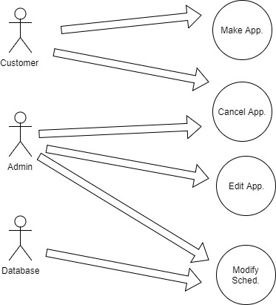

3.2.2. Textual Description for each use case

Within the website, there will be four different use-cases and three different uses. The uses will be the consumer, admin and database.

3.3. Rationale for your use case model

The use case model shows the relationship between the uses and the use-cases. The uses were consumer, admin, and database. The purpose of using these three uses was to present the three main uses that will be used when accessing the website. The use cases were make appointment, cancel appointment, cancel appointment, and modify appointment. The purpose of using these use-cases were to present the different things consumers can access on the scheduling system. The use-cases also show which uses relate to specific use-cases.

3.4. Non-functional requirements

The website’s non-functional requirements of performance, availability, reliability, maintainability and serviceability are all components that will be met. The performance of the website will be dependent on the Internet connection of the consumer. The availability of the website will be at 99% besides the maintenance hours that will be implemented. Reliability of the website will be at a high percentage due to the website staying steady with performance without crashing or other issues. Maintainability of the website will also be at a high level due to the developers keeping up with the website constantly to provide high performance for consumers. Service on the website will be kept up to date due to the developers keeping a high level of priority to maintain quality service to consumers.

4. Architecture

4.1. Architectural Design

The Architectural Design was a one page scrolling website something nice ad simple that could be worked on by all of us without much error

4.2. Technology, software, and hardware used

Technology used was a laptop for the making of the website and the design. Notepad++ for the coding, Excel, word, And PowerPoint for the PowerPoints and documents done.

4.3. Rationale for your architectural design.

The rationale for the design was something simple but well done that we could take our time on and perfect but also learn some new things along the way.

5. Design

5.1. GUI (Graphical User Interface) design

5.2. Static model – class diagrams

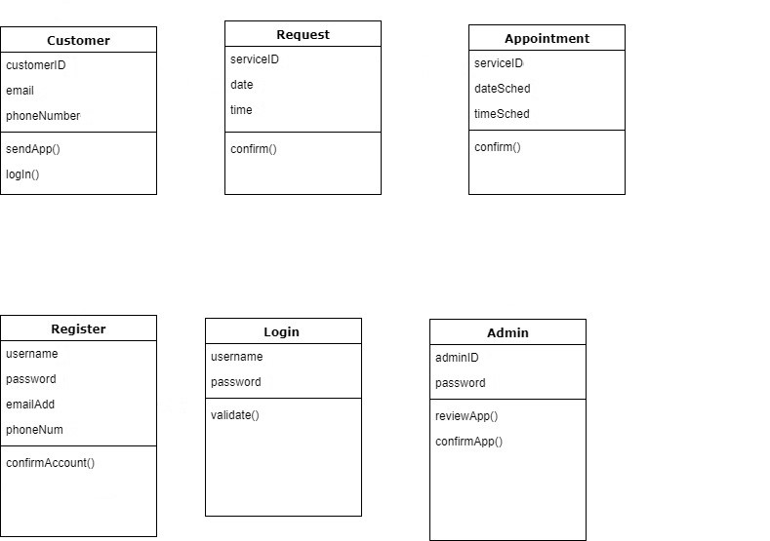

5.3. Dynamic model – DFD and/or sequence diagrams 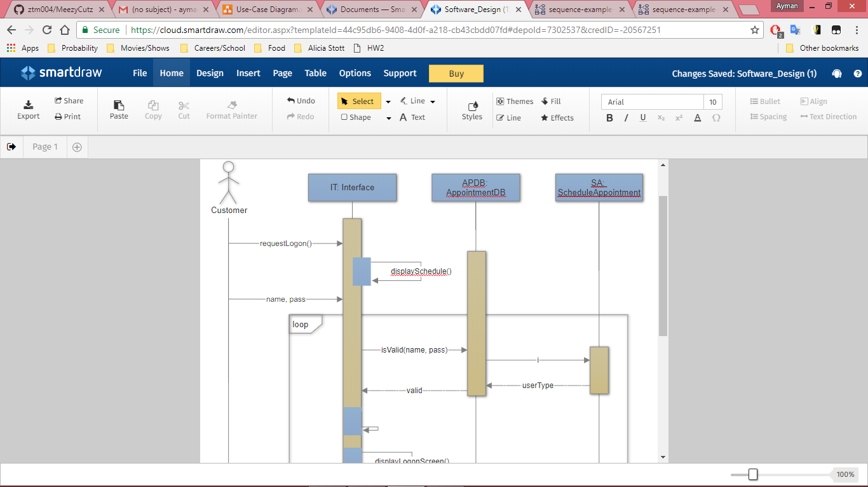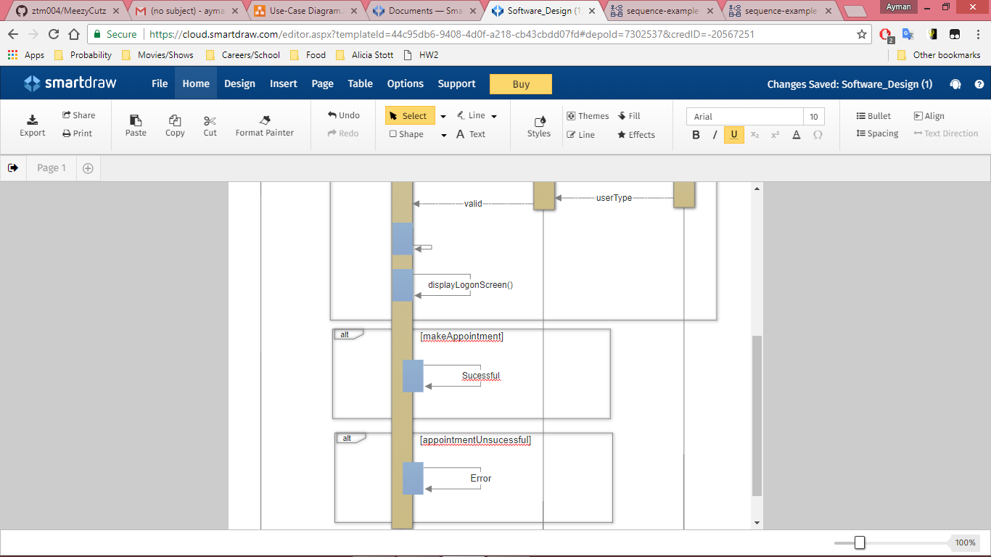

5.4. ERD, Database design

Third-Party database used for website.

5.4. Rationale for your detailed design model

The rationale for the design model was based on the prototyping that was done before implementing the website. When implementing, we targeted an appealing website design that would attract consumers into visiting the site and potentially become a customer in the near future.

6.1 Requirements

Requirements for testing consisted of creating a test user account and scheduling test appointments. Also ensured confirmation emails were sent to both the user and the barber, along with an appointment reminder and feedback email sent to user.

6.2 Class test Case

Test Cases:

* What if the appointment is not successfully processed?
* What if the customer is unable to login to their account?
* What if confirmation email does not send to the Admin?
* What if the site is down and appointments are lost?
* What will the admin receive from the database after an appointment?
* What if the database shuts down and clients are unable to book?

7. User Manual

Appendix A: Screen shots

Appendix B: Code